Project Fur Emblem
Working Title: Woodland
Gameplay Summary: Top-Down Turn-Based Strategy with woodland creatures versus army mainly consisting of insect enemies. Low poly style for level design and in game models. Themes of family and community. Varied endings and experiences based on decisions made to either work as individual or suffer for the sake of the community’s benefit. Cutscenes play out with low poly 3d models on screen with drawn art of the characters in bottom left speaking next to a dialog box.
Characters: Start out with Macy, Emma, and Penelope, adoptive sisters. Find more squad mates to add to militia as you go.
Macy is a precocious, reckless, and boisterous young otter woman with impressive magical powers and incredible intelligence. She has high offensive stats, but suffers with low defense and mobility stats, though she is agile in water. Possibility that her abilities even harm her, though it could be more in story than in mechanic. Macy sports a sizeable scar on her left eye due to an incident in her teenage years using magic. The scar wraps around to the back of her head so that you can see it from the top-down view during gameplay. She wears a simple fishing net and a rope belt where her favorite shells hang from. Macy wields no weapons, choosing to instead rely on her chaotic, but incredibly powerful lightning, fire, and water magic.
Emma is a big sister figure, a guiding hand to her younger adopted sisters. A brightly colored poisonous toad, Emma is a tough knight-type who uses her poison to zone opponents and keep them away from her sisters. Emma wears armor underneath a cloak, the cloak is primarily to protect others around her from being hurt by her poison accidentally. She wields a simple rock axe that she made herself.
Penelope is the youngest of the three and is a white stoat with an odd mutation: curly hair. She is by far the most energetic and starry-eyed with a blossoming passion for adventure as well as justice. She wears a hood and a belt for her knife.
Ant-agonists: Insect army led by Wasp Queen, perhaps possessed by spirit of ruin or some kind of ice age style apocalypse.
Story Summary: Within a world that primarily consists of small but intelligent animals, a thriving civilization of woodland creatures have taken up residence in a large area surrounding a large tree that provides the most shelter and protection, the Hearth Tree. Macy, Emma, and Penelope are three orphans who banded together at an early age and in their adulthood find themselves scavenging for food, working odd jobs for locals, or providing security detail as a small mercenary group.
Step-by-Step: Opening Scene of Macy, Emma, and Penelope searching and scavenging for food and they are attacked by a squad of ants.
Sample Dialogue:
Concept Art: Macy zapping ants from on top of hill, side-view, shadowy with light of lightning magic. Penelope pulling fish out of water while Emma holds out net trying to catch. Macy, Penelope, and Emma walking through a small town with straw roofs, Emma holding basket overflowing with supplies while Macy and Penelope talk animatedly.

Add. Notes:

Project Spooky College
No Working Title
Gameplay summary: Classic turn-based RPG with contemporary elements involving retro 2000s references and more modern setting both in battle and in overworld. 4 areas planned, all around the college as various segments of the school, dorms, fields, classes, and administration are all haunted by the evil spirit’s bosses of each area. Main menu with details about characters: likes, dislikes, majors, hobbies, hair color, etc. Character interactions, campsite time to bond with party members and saved students. Focus on items that become attacks in combat or have other effects in overworld. Some element of passive boosts chosen from list, like wristbands or something.
Characters:
Main girl: Wears casual clothes, skinny jeans and loose white t-shirt hangs around shoulders. Long black hair and freckles. Wields a switchblade and uses magic. Fierce and intelligent. Interested in occult, dark past.
Intro boy: Baseball cap, Bieber haircut or bowlcut, smug attitude. Wields a baseball bat and has techniques that give chance to deal extra damage or damage all enemies in homerun or pitching minigame at bottom of battle UI.
Plant boy: Grungy, tired, sweatpants and hoodie with hood tied closed covering eyes. Wields rake or gardening shears. After rescued from first boss, can mix items, potions for general healing, or poisons he can use in battle.

Story Summary: In the early 2000s, a group of college seniors throw a party in their dorm room to celebrate their upcoming graduation. At the end of the party, the group holds a séance and accidentally unleashes an evil spirit that possesses the entire college campus. As they fight through the four areas, dorms, fields, classes, and administration, the group discovers more about the dark past of the college and realize that the séance is not what freed the dark spirit.

Boss Ideas:
Plant monster terrorizing the dorms and covering it in vines. Came from student room who had lots of plants. Weed reference maybe. Use lit candles to deal extra damage.
Entire team of zombie football players, terrorizes area like stampede, section of area where you have to run away from them on the street without being trampled.
Ghost professor.
Released Evil Spirit, amalgamation of students murdered at the school,

Step-by-Step: Main character wakes up
Sample Dialogue:
Concept Art: Camera from behind, main girl summoning fiery wisps against plant boss,

Add. Notes:
Campy and Scary at the same time, retro 2000s references
2000s references:
Items: fushigi (mirror ball), zoo pals (animal plates), chia pets (clay plant animals), plastic arm grabbers, razor scooters, floam (sticky plastic sand), nickelodeon gak (funtoon slime), tickle me elmo (overpriced red monster), gamecube knockoff console (game hexagon), iPod (music brick), silly bands (Fun Wrists, or animal shaped wristbands)
Elements: text shorthand, no politics,

Project Kin
Working Title: Kin
Gameplay Summary: Sidescrolling puzzle platformer exploring a young tribal girl’s rite of passage. Inspired by Native American folklore and mythology, unsure if should be fully referenced or not yet. Cave painting style. Utilizing spirit animal for some kind of additional gameplay mechanic. Only dialogue at the end, narrative told through level design and background details like cave paintings and nature of spirit world.
Characters:
Main girl:

Story Summary:
Step-by-Step: Start with main character walking in desert exhausted. About halfway across the screen, she passes out. She wakes up in a trippy spirit world, after a short amount of time, she encounters her spirit animal and the primary mechanic of the game begins. Level design evolves along the way and MC collects aspects of maturity and adulthood at the end of each level, each giving a glimpse into her culture and the world she lives in.
Sample Dialogue:
Concept Art: 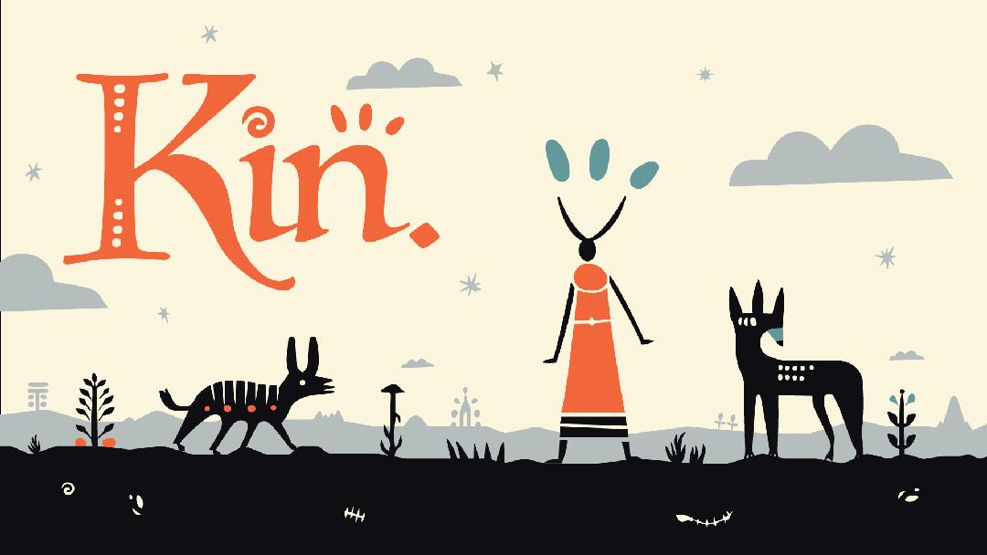
By Nick Wozniak

Add. Notes:

